

SCHOOL OF ENGINEERING
Department of Artificial Intelligence And Machine Learning
CERTIFICATE
This is to certify that the Cornerstone project work entitled "SIMPLE NOTES MANAGEMENT SYSTEM" is submitted by
MD. YASMEEN | (24B11AI261)
CH. GEETHIKA SRI | (24B11AI055)
B. LAVANYA | (24B11AI047)
N. DIVYA | (24B11AI280)

in partial fulfillment of the requirements for the award of the B.Tech. degree in Artificial Intelligence And Machine Learning for the academic year 2024-2028.

Project Guide  Mrs. K. Kavya Ramya Sree, _{M.Tech,( Ph.D)}  Assistant Professor,  Department of AIML | Head of the Department  Dr. M. Venkatesh, _{M.Tech, Ph.D,}  Associate Professor,  Department of AIML

DECLARATION
We hereby declare that the Cornerstone project entitled "SIMPLE NOTES MANAGEMENT SYSTEM" is original and is submitted to ADITYA UNIVERSITY, Surampalem, in partial fulfillment of the requirements for the award of the B.Tech. degree in Artificial Intelligence And Machine Learning. We further declare that this project work has not been submitted, either in full or in part, for the award of any degree in this or any other institution. We also confirm that this work complies with the Institutional Academic Integrity and AI Usage Policy.

Place: Surampalem
Date: 23-03-2026

By

MD. YASMEEN (24B11AI261)
CH. GEETHIKA (24B11AI055)
B. LAVANYA (24B11AI047)
N.DIVYA (24B11AI280)

ACKNOWLEDGEMENT
It is with immense pleasure that we express our sincere gratitude to our Cornerstone Project Guide, Mrs. K. Kavya Ramya Sree, Assistant Professor, who has guided us throughout the project. Her valuable support, encouragement, and guidance have greatly contributed to the successful completion of this work.
We would like to thank our Deputy Heads of the Department, Dr. R. Suneetha, Assistant Professor and Dr. A. Phani Sridhar, Assistant Professor, Department of AIML, for their support and valuable suggestions.
Our deepest thanks to our Head of the Department Dr. M. Venkatesh, Associate Professor, for his inspiration and for providing all the necessary facilities and resources required for this project.
We also extend our sincere thanks to Dr. M.V. Rajesh, Associate Dean, School of Engineering for their encouragement and support during the course of our project.
We would like to express our sincere gratitude to Dr. G. Suresh, Registrar, Dr. A Ramesh, Pro Vice-Chancellor (Engineering & Sciences), Dr. S. Rama Sree, Pro Vice-Chancellor (Academics), Dr. M.B. Srinivas, Vice-Chancellor, Dr. M. Sreenivasa Reddy, Deputy Pro Chancellor and Management, Aditya University for providing excellent infrastructure and state-of-the-art laboratories.
Finally, we would like to thank the faculty members, lab technicians, non-teaching staff, and our friends who have directly or indirectly supported us in completing this Cornerstone project successfully.

LIST OF CONTENTS
CONTENTS | PAGE NO

ABSTRACT
Chapter 1 : INTRODUCTION 01
1.1 Introduction 01
1.2 Problem Statement 01
1.3 Objectives of the Project 02
1.4 Scope of the Project 02
Chapter 2 : SYSTEM OVERVIEW 03
2.1 Existing System 03
2.2 Limitations of Existing System 03
2.3 Proposed System 04
2.4 Software Requirements 04
2.5 Hardware Requirements 05
Chapter 3 : TECHNOLOGIES USED 06
3.1 HTML 06
3.2 CSS 06
3.3 JAVASCRIPT 07
3.4 MySQL 07
3.5 VS CODE 07
Chapter 4 : SYSTEM ARCHITECTURE 08
4.1 Three Tier Architecture 08
4.2 Data Flow Diagram 09
Chapter 5 : DATABASE DESIGN 11
5.1 Users Data 11
5.2 Food Items Data 11
5.3 Cart Data 11
5.4 Orders Data 11
Chapter 6 : MODULE DESCRIPTION 12
6.1 Registration Module 12
6.2 Login Module 12
6.3 Menu Module 12
6.4 Main Dashboard Module 13
6.5 Quantity Selection Module 13
6.6 Add to Cart & Payment 13
Chapter 7 : OUTPUT SCREENS 14
7.1 Registration Screen 14
7.2 Login Screen 15
7.3 Menu Screen 16
7.4 Quantity Selection Screen 17
7.5 Add to Cart & Payment Screen 18
Chapter 8 : CONCLUSION 19
Chapter 9 : FUTURE ENHANCEMENTS 20
REFERENCES 21

LIST OF FIGURES

Figure No: Name of the Figure PageNo

- Figure 7.1: Registration Page 14

- Figure 7.2: Login Page 15

- Figure 7.3: Menu Page 17

- Figure 7.4: Quantity Selection Page 17

- Add to Cart & Payment Page 18

ABSTRACT
SIMPLE NOTES MANAGEMENT SYSTEM
The Notes Management System is a full-stack web application developed using the MERN stack—MongoDB, Express.js, React.js, and Node.js. The main purpose of this project is to provide users with an efficient way to create, store, organize, and manage digital notes. Users can perform all CRUD operations (Create, Read, Update, Delete) with a clean and responsive interface. The backend REST APIs ensure secure and structured communication with the database, while MongoDB stores user notes in a scalable manner. This project showcases the implementation of modern JavaScript technologies and demonstrates the core concepts of full-stack development, including state management, routing, API integration, authentication (optional), and responsive design. It is designed to be simple, fast, and user-friendly, making it ideal for students and beginners to understand MERN stack development.
SOFTWARE REQUIREMENTS:
- React.js – for building the front-end user interface.
- Node.js – for running the backend service.
- Express.js – for creating REST APIs.
- MongoDB – for storing the notes in the database.
HARDWARE REQUIREMENTS:
- Computer/Laptop with minimum 1.6 GHz processor
- 4 GB RAM (8 GB recommended)
- 20 GB free hard disk space
Team Names:
Md. Yasmeen -24B11AI261
Ch. Geethika -24B11AI055
B. Lavanya - 24B11AI047
N. Divya - 24B11AI280

CHAPTER 1- INTRODUCTION

1.1 Introduction
.The Notes Management System is a web application designed to help users create and manage notes efficiently.It is developed using the MERN stack, which includes MongoDB, Express.js, React.js, and Node.js.The application provides a user-friendly interface for adding, editing, viewing, and deleting notes.It supports secure user authentication, allowing only registered users to access their personal notes.The system stores data in a centralized database, ensuring easy access and management of information.This project replaces traditional note-taking methods with a digital solution that is faster and more reliable.
1.2 Problem Statement
In the current system, food ordering is done manually. Customers need to go to the vendor and place the order directly. This creates many problems. First, it takes more time because customers need to travel and wait for their order. Second, there is no proper system to manage orders, so mistakes can happen easily. Sometimes vendors may forget orders or prepare wrong items. Small vendors also face problems because they do not have any online presence. They cannot reach more customers and their business growth is limited. Big food delivery apps are not suitable for them because they charge high fees and require more setup. There is also no proper way to store customer details or order history. This makes it difficult to track orders or analyze business. So, there is a need for a simple and low-cost system that helps both customers and vendors

1.3 Objectives of the Project
- To provide an easy note-taking platform
Enable users to quickly create and store notes in a simple and user-friendly interface.

- To manage notes efficiently
Allow users to view, edit, update, and delete notes whenever needed.

- To ensure data organization
Help users organize notes systematically (e.g., by date, title, or category)
- To implement user authentication
Provide secure login and registration so that only authorized users can access their notes.

- To enable quick retrieval of information
Allow users to easily search and access their saved notes.

- To maintain data security
Ensure that user data is stored safely and protected from unauthorised access.

- To provide a responsive design
Make the system accessible on different devices like mobile, tablet, and desktop.

- To improve productivity.

- Help users manage their tasks and ideas efficiently in one centralised system. Information

1.4 Scope of the Project
The Simple Notes Management System is designed to provide a digital platform for users to create, manage, and organize their notes efficiently. The scope of this project includes the following:
- User Registration and Authentication
Users can create accounts, log in securely, and manage their personal profiles.
- Note Creation and Management
Users can add, view, edit, and delete notes as per their requirements.
- Data Storage and Retrieval
Notes are stored in a database and can be accessed anytime by the user.
- Search and Organization
Users can search notes and organize them based on titles, categories, or timestamps.
- Responsive User Interface
The system is accessible on multiple devices such as desktops, tablets, and smartphones.
- Basic Security Features
Includes password protection and secure handling of user data.
- CRUD Operations Implementation
Supports Create, Read, Update, and Delete functionalities for notes

CHAPTER 2 - SYSTEM OVERVIEW

2.1 Existing System

In the current scenario, users generally rely on traditional or basic methods to manage their notes, such as:

Paper-Based Notes
Writing notes in notebooks or diaries, which can be easily lost, damaged, or difficult to organize.

Basic Digital Tools
Using simple text editors (like Notepad) or unorganized files stored on devices without proper structure.

Lack of Organization
Notes are often scattered across multiple files or locations, making it hard to find specific information.

No Centralized System
There is no single platform to store and manage all notes efficiently.

Limited Accessibility
Notes stored locally cannot be accessed from different devices or locations easily.

No Security Features
Traditional methods do not provide secure access or user authentication.

2.2 Limitations of Existing System

The existing manual system has several limitations:
• High chances of mistakes while taking notes manually
• Time-consuming process as customers need to visit and wait
• No proper record of notes and content details
• Difficult to handle multiple onotes during busy hours
• Limited data reach (only nearby people)
• No notes tracking system
• More manual work for systems
• Chances of missing or delayed notes
2.3 Proposed System
The proposed system is a web-based Simple Notes Management System designed to overcome the limitations of the existing system by providing a secure, organized, and user-friendly platform for managing notes digitally.
- User Authentication System
Users can register and log in securely to access their personal notes.
- Efficient Note Management
Users can easily create, view, edit, and delete notes using simple interfaces.
- Centralized Data Storage
All notes are stored in a database, allowing easy access and management from a single platform.
- Search and Organization Features
Users can search notes quickly and organize them using titles, categories, or timestamps.
- Responsive User Interface
The system is designed to work smoothly on desktops, tablets, and mobile devices.
- Data Security and Privacy
User data is protected through secure authentication and proper data handling techniques.
- Real-Time Updates
Changes made to notes are reflected immediately without delays.
- Scalable Architecture
The system can be expanded in the future to include advanced features like sharing notes or cloud backup.

2.4 Software Requirements

1. Frontend Requirements

Technologies: HTML, CSS, JavaScript

Framework (optional): React.js

Browser Support: Google Chrome, Microsoft Edge, Firefox

UI Features:

Responsive design

User-friendly interface

Forms for login, registration, and notes

2. Backend Requirements

Runtime Environment: Node.js

Framework: Express.js

API Type: RESTful APIs

Functions:

Handle user authentication

Process CRUD operations for notes

Manage server requests and responses

3. Database Requirements

Database: MongoDB

Tools: MongoDB Atlas / Local MongoDB

2.5 Hardware Requirements
The hardware requirements for the system are:
• Processor: Intel i3 or higher
• RAM: Minimum 4 GB
• Hard Disk: At least 10 GB free space
• Monitor and keyboard
• Internet connection

1. Development System (Minimum Requirements)
- Processor: Intel Core i3 or equivalent
- RAM: 4 GB (8 GB recommended for better performance)
- Storage: 256 GB HDD/SSD
- Display: Standard monitor (1366 × 768 resolution or higher)
- Input Devices: Keyboard and Mouse

2. Server Requirements (for Deployment)
- Processor: Intel Core i5 or higher
- RAM: 8 GB or more
- Storage: 500 GB or higher (SSD preferred)
- Network: Stable internet connection
- Cloud Option (Optional): Can be deployed on cloud servers

3. Client System (End Users)
- Device: Desktop / Laptop / Smartphone / Tablet
- RAM: Minimum 2 GB
- Browser: Chrome, Edge, Firefox, or any modern browser
- Internet: Required for accessing the application

CHAPTER 3 - SYSTEM IMPLEMENTATION

The implementation of the Notes Management System involves the integration of various web technologies to create a functional, responsive, and user-friendly digital workspace. The following tools and languages were utilized to build the system:

3.1 HTML (Hyper Text Markup Language)

HTML serves as the fundamental structural framework for the Notes Management System. It is used to define the layout of the application, including the login portal, the primary dashboard, the note creation forms, and the category selection menus.

In this project, HTML elements such as <textarea> for note bodies, <input> for titles and search queries, and <button> for saving or deleting notes are used to organize content. HTML ensures that the information is presented in a logical hierarchy, making the application accessible and easy to navigate for the user.

3.2 CSS (Cascading Style Sheets)

CSS is employed to transform the basic HTML structure into a visually appealing and professional interface. For a notes application, CSS is crucial in creating a clean, "paper-like" feel that minimizes distractions. It is used to manage typography, spacing, and color schemes that distinguish between different note categories (e.g., using blue for "Work" and green for "Personal").

Furthermore, CSS ensures the application is responsive, allowing the user to view and edit their notes comfortably on both desktop monitors and mobile screens. Modern styling techniques like Flexbox and Grid are used to arrange the notes in an organized dashboard layout.

3.3 JavaScript

JavaScript is the core programming language that provides the "intelligence" and interactivity of the system. In this application, JavaScript handles the CRUD (Create, Read, Update, Delete) logic. It enables real-time actions such as filtering notes as the user types in the search bar, opening modal windows for editing, and triggering auto-save features.

JavaScript also handles form validation, ensuring that a user does not save an empty note or attempt to register with an invalid email. By manipulating the Document Object Model (DOM), JavaScript allows the dashboard to update instantly without needing to refresh the page.

3.4 LocalStorage (Data Persistence)
While traditional systems might use MySQL, this project utilizes Web Storage (localStorage) to maintain a lightweight and serverless profile. LocalStorage acts as the system's database, allowing note data to be stored directly in the user's browser as stringified JSON objects.
This implementation ensures that the user's data remains persistent. Even if the browser is closed or the computer is restarted, the JavaScript logic can retrieve the saved strings from localStorage and parse them back into viewable notes upon the next visit. This provides a fast, private, and efficient data management solution for a personal productivity tool.

3.5 VS Code (Development Tool)

Visual Studio Code (VS Code) was the primary Integrated Development Environment (IDE) used for this project. Its lightweight nature and powerful features, such as IntelliSense for code completion and the Live Server extension for real-time testing, greatly accelerated the development process.
VS Code’s built-in terminal and Git integration allowed for organized version control and efficient debugging of the JavaScript logic. By using this tool, the development of the Notes Management System remained structured, clean, and error-free.

CHAPTER 4 - SYSTEM ARCHITECTURE
The Notes Management System follows a structured three-tier web application architecture. This design separates the user interface, application logic, and data storage to ensure the system is easy to maintain and scale.
The architecture ensures that the frontend communicates with the logic layer via user actions (like typing notes or clicking "Save"), while the logic layer manages the processing and retrieval of data from the storage layer. As a lightweight application, it operates entirely within the browser environment using JavaScript and localStorage.

4.1 Three-Tier Architecture
4.1.1 Presentation Tier (Frontend)
The Presentation Tier is the user-facing layer, developed using HTML5, CSS3, and JavaScript. It provides an intuitive interface for managing personal information.
- Login/Registration Pages: Secure entry points for users to manage their private notes.
- Dashboard/Home Page: Displays a grid or list view of all saved notes with search and filter options.
- Note Editor: An interface to create and edit titles, content, and categories.
- Archived/Trash View: Separate sections for organized storage or deleted notes.

4.1.2 Application Tier (Logic Layer)
The Application Tier acts as the "brain" of the system. Implemented in JavaScript, it handles the following core functionalities:
- Authentication Logic: Verifying login credentials against stored user data.
- CRUD Operations: Logic for Creating, Reading, Updating, and Deleting notes.
- Search and Filter Logic: Sorting notes by date, category (e.g., Work, Personal), or keyword.
- Auto-save Functionality: Ensuring data is captured dynamically as the user types.
- Input Validation: Checking for empty titles or character limits.

4.1.3 Data Tier (Storage Layer)
Instead of a complex database, this system utilizes browser localStorage to store data in key-value pairs. This allows the user's notes to persist even after the browser is closed or refreshed.
- User Data: Stores usernames, hashed passwords, and preferences.
- Notes Data: Stores the title, body text, timestamp, and category tags for each note.
- Settings: Stores theme preferences (e.g., Light vs. Dark mode).

4.2 Data Flow Diagram (DFD)
Gemini said
To adapt your documentation for a Simple Notes Management Project, we need to shift the focus from food items and orders to categories, tags, and note-taking functionality.
Here is the revised Chapter 4 based on your architecture requirements.

CHAPTER 4 - SYSTEM ARCHITECTURE
The Notes Management System follows a structured three-tier web application architecture. This design separates the user interface, application logic, and data storage to ensure the system is easy to maintain and scale.
The architecture ensures that the frontend communicates with the logic layer via user actions (like typing notes or clicking "Save"), while the logic layer manages the processing and retrieval of data from the storage layer. As a lightweight application, it operates entirely within the browser environment using JavaScript and localStorage.
4.1 Three-Tier Architecture
4.1.1 Presentation Tier (Frontend)
The Presentation Tier is the user-facing layer, developed using HTML5, CSS3, and JavaScript. It provides an intuitive interface for managing personal information.
- Login/Registration Pages: Secure entry points for users to manage their private notes.
- Dashboard/Home Page: Displays a grid or list view of all saved notes with search and filter options.
- Note Editor: An interface to create and edit titles, content, and categories.
- Archived/Trash View: Separate sections for organized storage or deleted notes.
4.1.2 Application Tier (Logic Layer)
The Application Tier acts as the "brain" of the system. Implemented in JavaScript, it handles the following core functionalities:
- Authentication Logic: Verifying login credentials against stored user data.
- CRUD Operations: Logic for Creating, Reading, Updating, and Deleting notes.
- Search and Filter Logic: Sorting notes by date, category (e.g., Work, Personal), or keyword.
- Auto-save Functionality: Ensuring data is captured dynamically as the user types.
- Input Validation: Checking for empty titles or character limits.

4.1.3 Data Tier (Storage Layer)
Instead of a complex database, this system utilizes browser localStorage to store data in key-value pairs. This allows the user's notes to persist even after the browser is closed or refreshed.
- User Data: Stores usernames, hashed passwords, and preferences.
- Notes Data: Stores the title, body text, timestamp, and category tags for each note.
- Settings: Stores theme preferences (e.g., Light vs. Dark mode).

4.2 Data Flow Diagram (DFD)
Level-0 DFD (Context Diagram)
The system involves one primary entity: the User. The User sends inputs such as note content and login credentials to the Notes Management System. The system provides outputs such as the rendered list of notes and status notifications (e.g., "Note Saved").
Level-1 DFD
The system is divided into four main processes:
- User Authentication: Manages signup and login sessions.
- Note Management: Handles the creation and modification of note content.
- Search & Organization: Processes filters and category assignments.
- Storage Synchronization: Manages the writing and reading of strings to localStorage.

4.3 Entity Relationship (ER) Diagram
Gemini said
To adapt your documentation for a Simple Notes Management Project, we need to shift the focus from food items and orders to categories, tags, and note-taking functionality.
Here is the revised Chapter 4 based on your architecture requirements.

CHAPTER 4 - SYSTEM ARCHITECTURE
The Notes Management System follows a structured three-tier web application architecture. This design separates the user interface, application logic, and data storage to ensure the system is easy to maintain and scale.
The architecture ensures that the frontend communicates with the logic layer via user actions (like typing notes or clicking "Save"), while the logic layer manages the processing and retrieval of data from the storage layer. As a lightweight application, it operates entirely within the browser environment using JavaScript and localStorage.
4.1 Three-Tier Architecture
4.1.1 Presentation Tier (Frontend)
The Presentation Tier is the user-facing layer, developed using HTML5, CSS3, and JavaScript. It provides an intuitive interface for managing personal information.
- Login/Registration Pages: Secure entry points for users to manage their private notes.
- Dashboard/Home Page: Displays a grid or list view of all saved notes with search and filter options.
- Note Editor: An interface to create and edit titles, content, and categories.
- Archived/Trash View: Separate sections for organized storage or deleted notes.
4.1.2 Application Tier (Logic Layer)
The Application Tier acts as the "brain" of the system. Implemented in JavaScript, it handles the following core functionalities:
- Authentication Logic: Verifying login credentials against stored user data.
- CRUD Operations: Logic for Creating, Reading, Updating, and Deleting notes.
- Search and Filter Logic: Sorting notes by date, category (e.g., Work, Personal), or keyword.
- Auto-save Functionality: Ensuring data is captured dynamically as the user types.
- Input Validation: Checking for empty titles or character limits.
4.1.3 Data Tier (Storage Layer)
Instead of a complex database, this system utilizes browser localStorage to store data in key-value pairs. This allows the user's notes to persist even after the browser is closed or refreshed.
- User Data: Stores usernames, hashed passwords, and preferences.
- Notes Data: Stores the title, body text, timestamp, and category tags for each note.
- Settings: Stores theme preferences (e.g., Light vs. Dark mode).

4.2 Data Flow Diagram (DFD)
Level-0 DFD (Context Diagram)
The system involves one primary entity: the User. The User sends inputs such as note content and login credentials to the Notes Management System. The system provides outputs such as the rendered list of notes and status notifications (e.g., "Note Saved").
Level-1 DFD
The system is divided into four main processes:
- User Authentication: Manages signup and login sessions.
- Note Management: Handles the creation and modification of note content.
- Search & Organization: Processes filters and category assignments.
- Storage Synchronization: Manages the writing and reading of strings to localStorage.

4.3 Entity Relationship (ER) Diagram
The ER diagram for this system focuses on the organization of personal information:
Main Entities:
- User: Stores personal details and account settings.
- Note: Stores the core content, including Title and Body.
- Category/Tag: Defines labels used to group notes.
- Attachment (Optional): Stores links or metadata for files attached to notes.

Relationships:
- One User can create Many Notes.
- One Note can belong to One Category (or many, if using tags).
- One Category can contain Many Notes.

CHAPTER 5- DATABASE DESIGN

The database design for the Notes Management System is structured to store, organize, and retrieve text-based information efficiently. In this project, rather than employing a complex database server like MySQL or MongoDB, data is managed using the browser’s localStorage.

localStorage provides a persistent storage mechanism within the user's web browser. Data is saved as key-value pairs, ensuring that the notes remain available even after the browser window is closed or the page is refreshed. This approach is ideal for a lightweight, privacy-focused notes application.

The system’s data is categorized into three primary structures: user credentials, note content, and category/tag metadata.

5.1 Users Data

The Users data stores information required for account management and security. Since this is a client-side application, user data is primarily used to create a personalized environment and simulate a multi-user login experience.

Fields: Full Name, Username, Password (hashed/encrypted), and Email.

Usage: This data is captured during registration and referenced during the login process to grant access to the user's private dashboard.

5.2 Notes Data

This is the core dataset of the application. It contains the actual content created by the user. Each note is stored as an object within a larger array in localStorage.

Fields: Note ID (Unique), Title, Content (Body text), Date Created, and Last Modified Timestamp.

Usage: The logic layer retrieves this data to populate the dashboard and allows the user to view, edit, or delete specific entries.

5.3 Categories and Tags Data

To prevent the notes from becoming cluttered, the system uses a data structure for organization. This allows users to group related notes together.

Fields: Category Name (e.g., "Work," "Personal," "Ideas"), Color Code, and Associated Note IDs.

Usage: This data is used to populate sidebar filters and dropdown menus, enabling the user to sort through large volumes of notes quickly.

5.4 Archive and Trash Data

To ensure a smooth user experience, the system maintains a temporary data section for deleted or hidden notes.

Fields: Note ID, Original Location, and Deletion Date.

Usage: When a note is "deleted," it is moved to this data section rather than being permanently erased immediately. This allows for a "Restore" functionality, protecting the user against accidental data loss.

CHAPTER-6 MODULE DESCRIPTION

6.1 Registration Module
The Registration Module is used for creating a new user account in the system. This module is mainly for new users who want to use the food delivery application.
In this module, the user needs to enter details such as name, username, password, phone number, and delivery address. These details are important for identifying the user and for delivering food to the correct location.
After entering the details, the user clicks on the register button. The system stores this information in the browser using localStorage. This allows the user to log in later using the same credentials.

6.2 Login Module
The Login Module is used to provide secure access to the system. Only users who have registered can log in and use the application.
In this module, the user enters their username and password. The system checks these details with the stored data in localStorage. If the entered details are correct, the user is successfully logged in and redirected to the main menu page.
If the details are incorrect, the system shows an error message and asks the user to enter correct information. This helps in preventing unauthorized access.
6.3 Menu Module
The Menu Module is one of the most important parts of the Food Delivery System. It is used to display all available food items in a clear and organized way so that users can easily select their desired items.
After successful login, the user is redirected to the menu page. In this module, food items are divided into different categories such as All, Tiffins, Lunch, Snacks, and Desserts. The “All” category shows all food items together, while other categories help users to filter items based on their preference.

6.4 Main Dashboard Module
The Main Dashboard is the central page of the Food Delivery System where users can access all the main features of the application. After successful login, the user is redirected to this dashboard.
The dashboard mainly displays the food menu section, where users can view all available items. It includes category options like All, Tiffins ,Lunch, Snacks, and Desserts, which help users to filter and select food items easily.
From the main dashboard, users can perform multiple actions such as browsing food items, adding items to the cart, viewing selected items, and placing orders. It acts as the main control area of the system.
The dashboard is designed in a simple and user-friendly way so that users can easily navigate between different sections without confusion. Important options like Cart, Logout, and Menu are easily accessible from this page.
6.5 Quantity Selection
The Quantity Selection Module is used when the user wants to add a food item to the cart. It helps the user choose how many items they want to order.
When the user clicks on the “Add to Cart” button in the menu, a small popup or input box appears. In this, the user can enter the quantity of the selected item.
After entering the quantity, the user confirms the action. The system then adds the selected item along with the specified quantity to the cart. This allows users to order multiple items easily.
This module is useful because different users may want different quantities of the same item. It gives flexibility and control to the user while placing the order.
The quantity selection is designed in a simple way so that users can easily understand and use it without confusion. It also helps in calculating the total price based on the quantity selected.

6.6 Add to Cart & Payment
When the user clicks on the Add to Cart button, a popup appears to enter the required quantity. The user enters the number of items and clicks OK. The selected quantity is then added to the cart. This helps in placing accurate and easy orders

CHAPTER 7- OUTPUT SCREEN SHOTS

7.1 Registration Module
The Registration Module is the entry point for new users to create a personal account within the system. Since notes often contain private or sensitive information, this module ensures that each user has a dedicated space for their data.
In this module, the user provides details such as their name, email, and a secure password. These credentials are vital for creating a unique profile. Once the "Sign Up" button is clicked, the system validates the input and stores the encrypted data in localStorage, allowing the user to access their saved notes in future sessions.

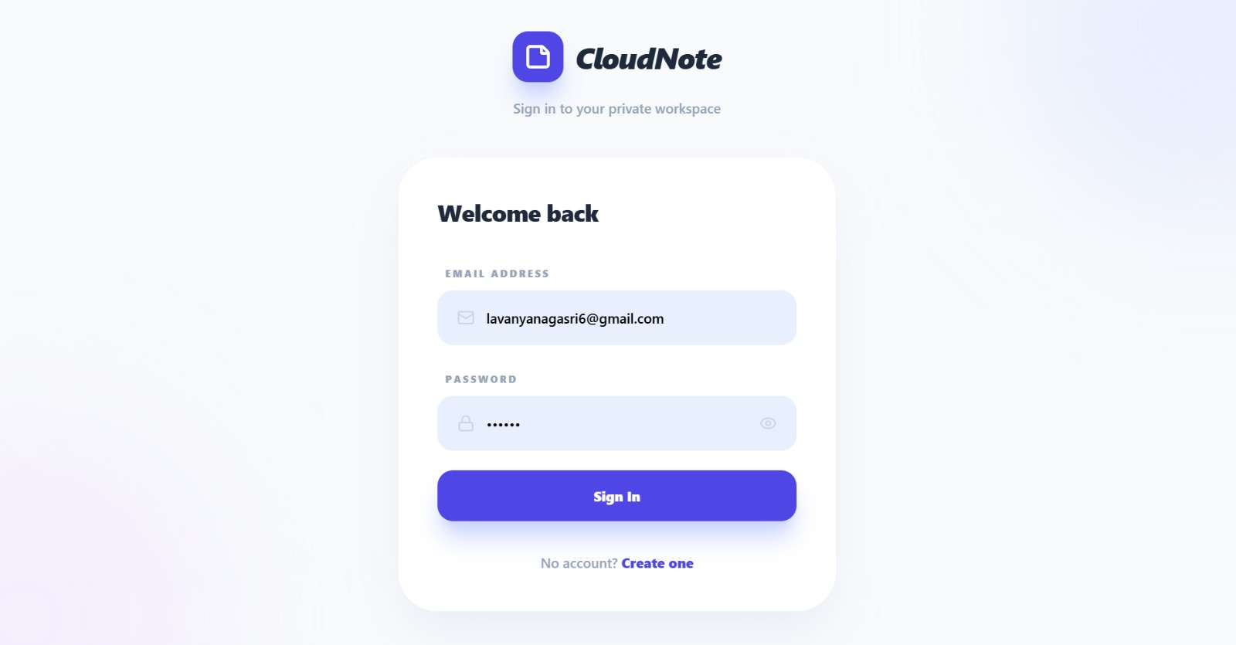

7.2 Login Module
The Login Module serves as the security gatekeeper for the application. It ensures that only authorized individuals can view, edit, or delete existing notes.
The user enters their registered username and password, which the system cross-references with the data stored in the browser's storage. If the credentials match, the user is granted access to their private dashboard. If the information is incorrect, a clear error message is displayed to prevent unauthorized entry, maintaining the privacy of the stored information.

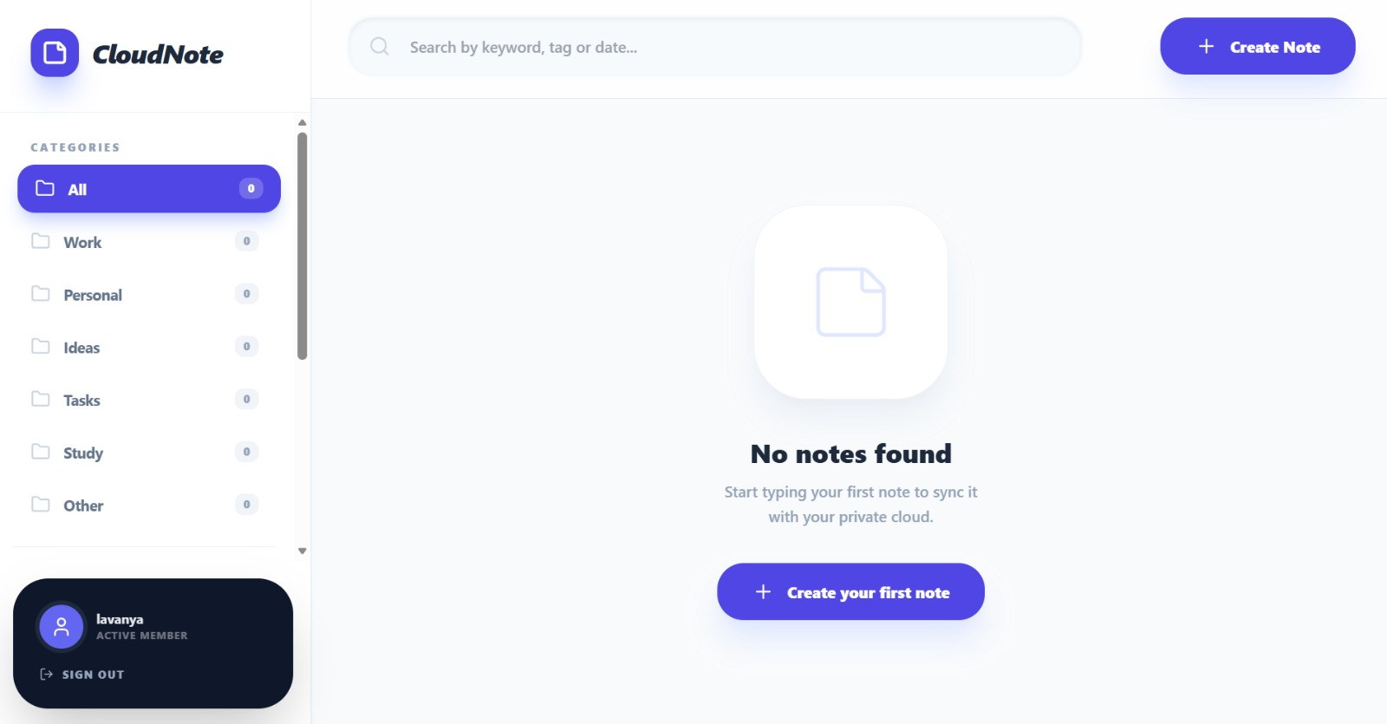

7.3 Note Creation & Editor Module

The Note Creation Module is the core functional area where users generate new content. It provides a clean, distraction-free interface for writing.

This module includes fields for a Note Title and a Content Body. Users can type their thoughts, lists, or reminders in real-time. The editor may also include features like character counting or category tagging. Once the "Save" action is triggered, the logic layer assigns a unique ID and timestamp to the note before committing it to the data tier.

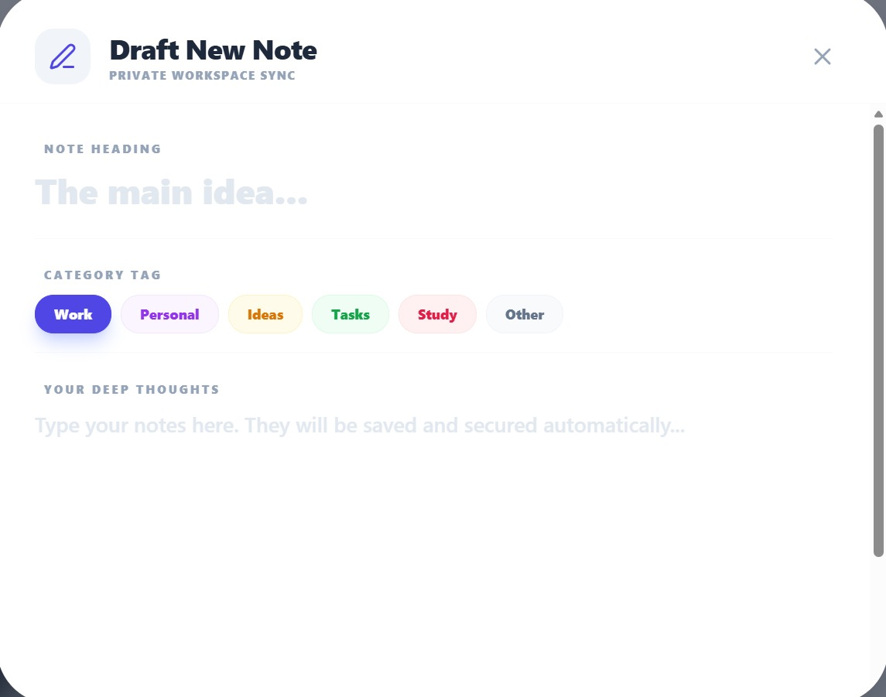

7.4 Main Dashboard Module

The Main Dashboard is the central hub of the Notes Management System. It provides an overview of all saved information and acts as the primary navigation control for the user.

The dashboard displays a grid or list of all existing notes, showing snippets of content for quick recognition. It includes a Search Bar to find specific notes by keyword and a Filter Sidebar to view notes by category (e.g., Work, Personal, Urgent). From this dashboard, users can easily navigate to create a new note, edit an old one, or manage their account settings.

7.5 Category & Tagging Module
The Category Management Module allows users to organize their notes systematically. Instead of a cluttered list, users can group related information together.
When creating or editing a note, the user can select a category from a dropdown menu or create a new tag. This module helps in structuring data effectively, making it easier to retrieve specific sets of information later. It gives the user flexibility and control over how their digital workspace is organized.

CHAPTER 8 – CONCLUSION
The system architecture of the Notes Management System explains how the application is structured and how its various components collaborate to facilitate efficient information storage and retrieval. It provides a comprehensive view of the application’s framework and the flow of user data through the digital environment.
The system is organized into three distinct layers: the Presentation Layer, the Logic Layer, and the Data Storage Layer. Each layer serves a specific purpose, working in harmony to ensure a seamless note-taking experience for the user.
- The Presentation Layer serves as the front-end interface of the system. Built using HTML5, CSS3, and JavaScript, this layer includes all user-facing screens such as the login portal, the main notes dashboard, the text editor, and the category management view. It is responsible for capturing user input—such as typing note content or searching for keywords—and rendering the output clearly. The design focuses on minimalism and responsiveness, ensuring that users can manage their thoughts easily across different devices.
- The Logic Layer acts as the functional core of the application. It manages all backend-simulated operations, including user authentication, the creation and editing of notes, dynamic searching, and the categorization of entries. It validates user actions, such as ensuring a note has a title before saving, and controls the behavior of the system to ensure data integrity. This layer is responsible for the "intelligence" of the app, such as automatically generating timestamps for each note.
- The Data Storage Layer is dedicated to preserving all application data. In this project, data is persisted using the browser's localStorage rather than a traditional server-side database. This layer securely stores user profiles, note bodies, and organizational tags in a structured format. By leveraging local storage, the system ensures that the user's information remains available across browser sessions, allowing for a reliable and private note-management solution.

CHAPTER 9 – FUTURE ENHANCEMENTS

The current Notes Management System provides essential functionalities such as user authentication, note creation, categorization, and persistent storage. While the application is fully functional for personal use, it can be significantly improved by incorporating advanced features. Some possible enhancements for the future include:

Advanced Text Editing: Integrating a Rich Text Editor (WYSIWYG) to allow bolding, italics, bullet points, and hyperlinking within notes.

Cloud Synchronization: Transitioning from localStorage to a cloud database (like Firebase or MongoDB) to allow users to access their notes across multiple devices.

Multimedia Attachments: Enabling users to attach images, voice recordings, or PDF documents to their notes.

Collaboration Features: Adding a "Share" option to allow multiple users to view or edit the same note in real-time.

Reminder Notifications: Implementing a task-based system with push notifications or email alerts for time-sensitive notes.

Security Upgrades: Adding biometric authentication (Fingerprint/FaceID) for mobile browsers and two-factor authentication (2FA).

Dark Mode & Custom Themes: Providing a wider range of visual themes to reduce eye strain and improve user experience.

Archival and Version History: Allowing users to view previous versions of a note to track changes or recover accidentally deleted text.

Offline Support (PWA): Converting the system into a Progressive Web App so it can be installed on home screens and function without an internet connection.

AI-Powered Summarization: Integrating AI to automatically summarize long notes or suggest relevant tags based on the content.

Reference Links for Enhancements

Rich Text Editing: https://www.tiny.cloud/docs/

Cloud Storage (Firebase): https://firebase.google.com/docs/database

PWA Development: https://developer.mozilla.org/en-US/docs/Web/Progressive_web_apps

Push Notifications: https://developer.chrome.com/docs/extensions/mv3/notifications/

Encryption & Security: https://developer.mozilla.org/en-US/docs/Web/API/Web_Crypto_API

UI/UX Frameworks (Tailwind): https://tailwindcss.com/docs

Voice-to-Text Integration: https://developer.mozilla.org/en-US/docs/Web/API/Web_Speech_API

Collaboration (Socket.io): https://socket.io/docs/v4/

Version Control Logic: https://git-scm.com/doc

PDF Exporting: https://parallax.github.io/jsPDF/

REFERENCES
The following references were used for developing the Notes Management System:
- W3Schools – HTML, CSS, and JavaScript tutorials for building the user interface.
- MDN Web Docs – Comprehensive documentation on localStorage and JavaScript DOM manipulation.
- YouTube – Video tutorials related to CRUD (Create, Read, Update, Delete) application logic.
- Stack Overflow – Community support for debugging logic errors and data persistence issues.
- Google – Researching productivity tool layouts and user experience patterns.
- Visual Studio Code Documentation – Guide for using the IDE to develop and debug web applications.

- Google Keep Official Website. [Online]. Available: https://keep.google.com
- Evernote Official Website. [Online]. Available: https://www.evernote.com
- Notion Official Website. [Online]. Available: https://www.notion.so
- JavaScript Info. "Local storage, sessionStorage." [Online]. Available: https://javascript.info/localstorage
- MDN Web Docs. "Using the Web Storage API." [Online]. Available: https://developer.mozilla.org/en-US/docs/Web/API/Web_Storage_API/Using_the_Web_Storage_API
- W3Schools. "JavaScript HTML DOM." [Online]. Available: https://www.w3schools.com/js/js_htmldom.asp
- Bootstrap Documentation. [Online]. Available: https://getbootstrap.com
- Ian Sommerville, Software Engineering, 10th Edition, Pearson, 2015.
- Pressman, R. S., Software Engineering: A Practitioner’s Approach, McGraw-Hill, 2014.
- Don Norman, The Design of Everyday Things (for UI/UX principles), Basic Books, 2013.

